**User Interface Design**

**Version 1.1**

**Project Management App**

**Team A**

**CSC-354**

**Fall 2015**



11/12/2015

Author:

Submitted To: Dr. Joo Tan

**TABLE OF CONTENTS**

Revision History…………………………………………………………………………………..ii

1.0 Introduction……..….....…………………………….…...…………………………….……....1

1.1 What Is User Interface Design?............………....……………………………….........1

**REVISION HISTORY**

|  |  |  |  |
| --- | --- | --- | --- |
| Version | Author | Description | Date |
| 1.0 | Hector Richiez | I created the frame that will be using for UID | 11/08/2015 |
| 1.1 | Tyler Mariano | I created the screen flow diagram and added all fifteen screen wireframe diagrams to the document. | 11/11/2015 |

**1.0 INTRODUCTION**

**1.1 what is User Interface Design?**

flow

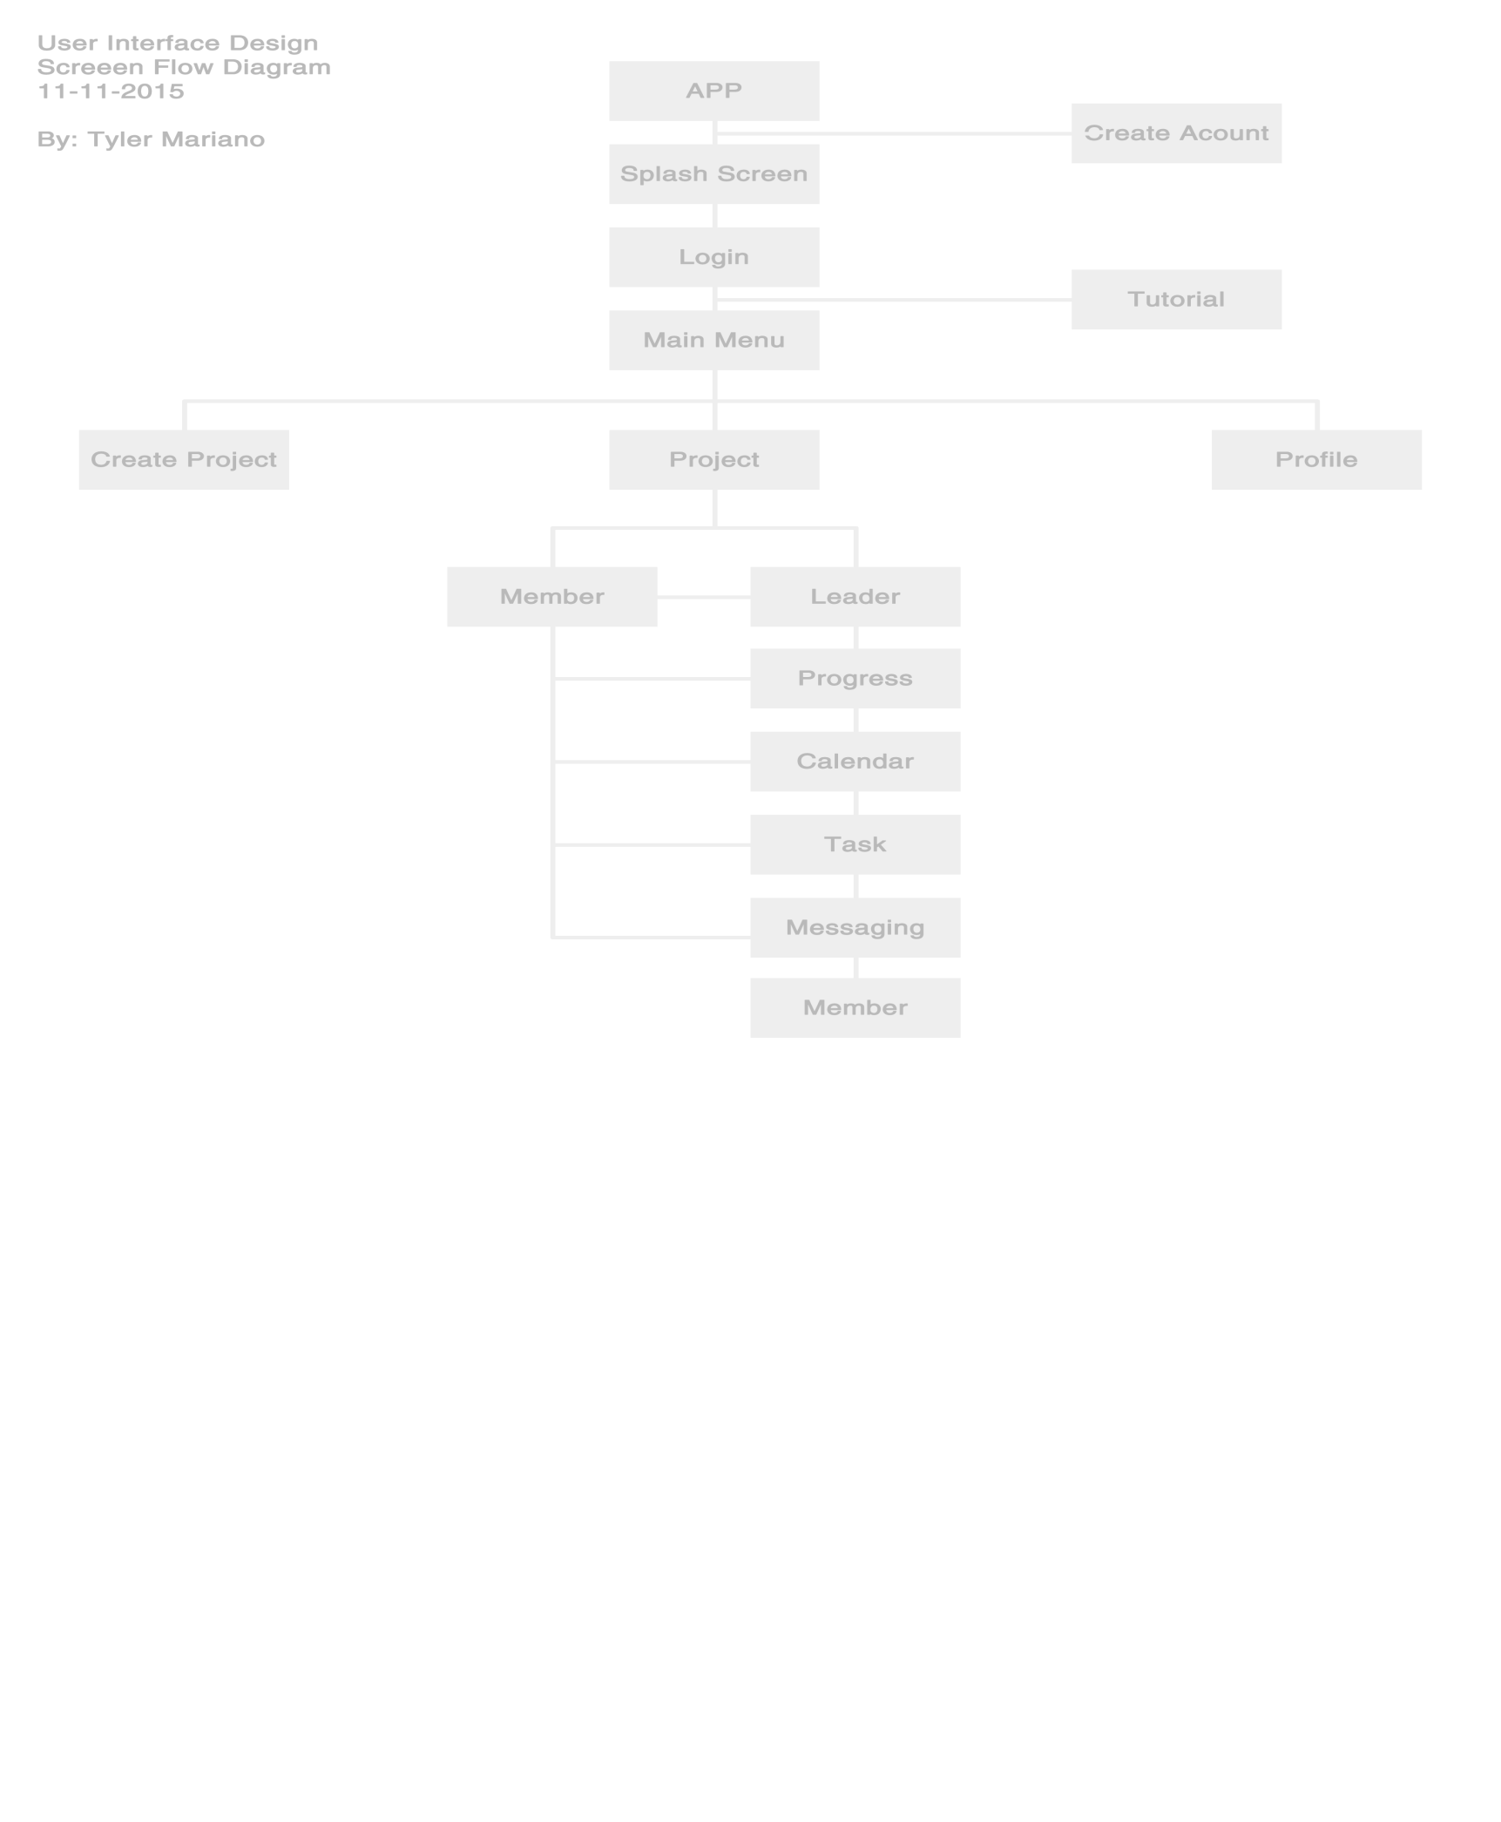

**3.1 Initial Window**

The initial window (see figure 3.1) of the App will be an icon that the user will click to start running the application.



**3.2 SPLASH SCREEN**

**Info**

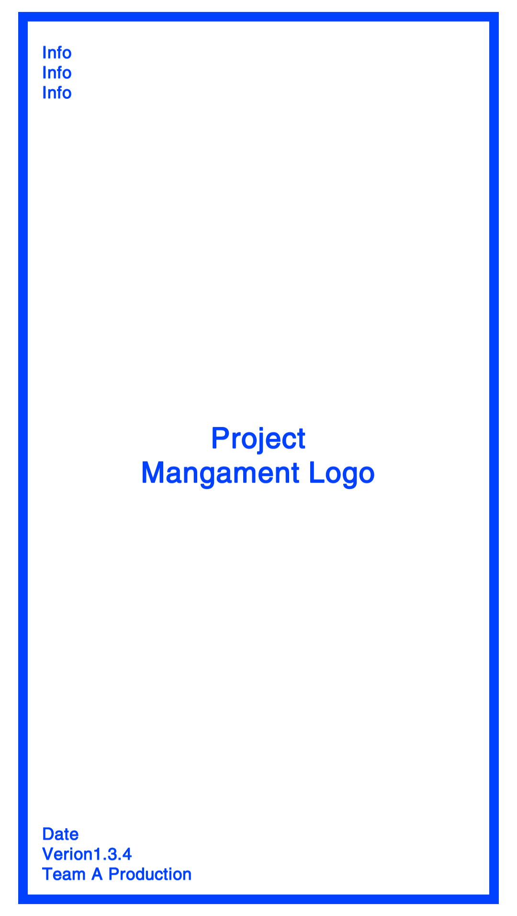

**3.2 Create Account Window**

The create account window (see figure 3.2) will ask the user to create an account by providing the system with a user name and a password. The user will be able to enter the password for a second time to validate user input. After the user has filled out the 3 text boxes, the enter button will be available for the user to click and create the account.

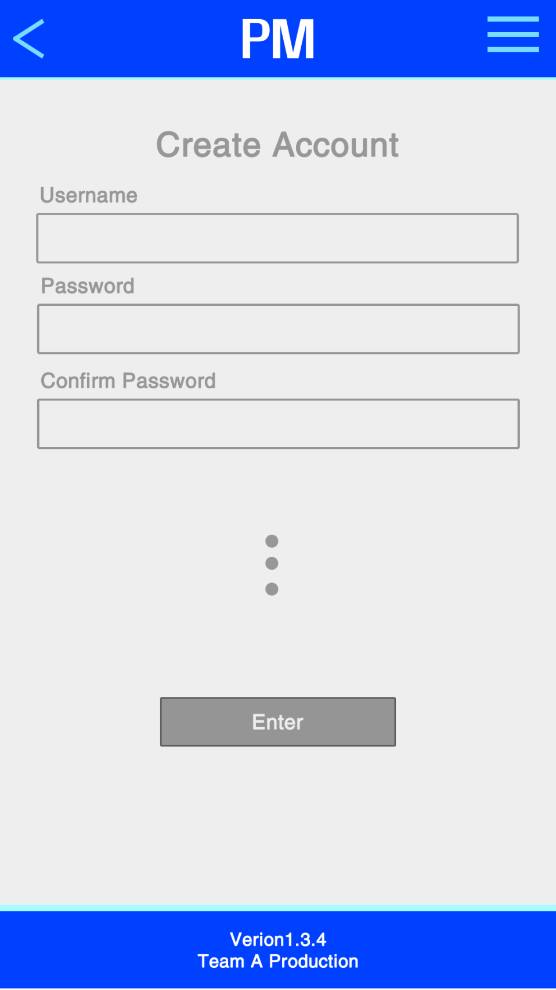

**3.4 Login Window**

The login window (see figure 3.4) asks the user for a user password and a username. When both textboxes are filled with the information the login button will be available for the user to click to login to the APP.

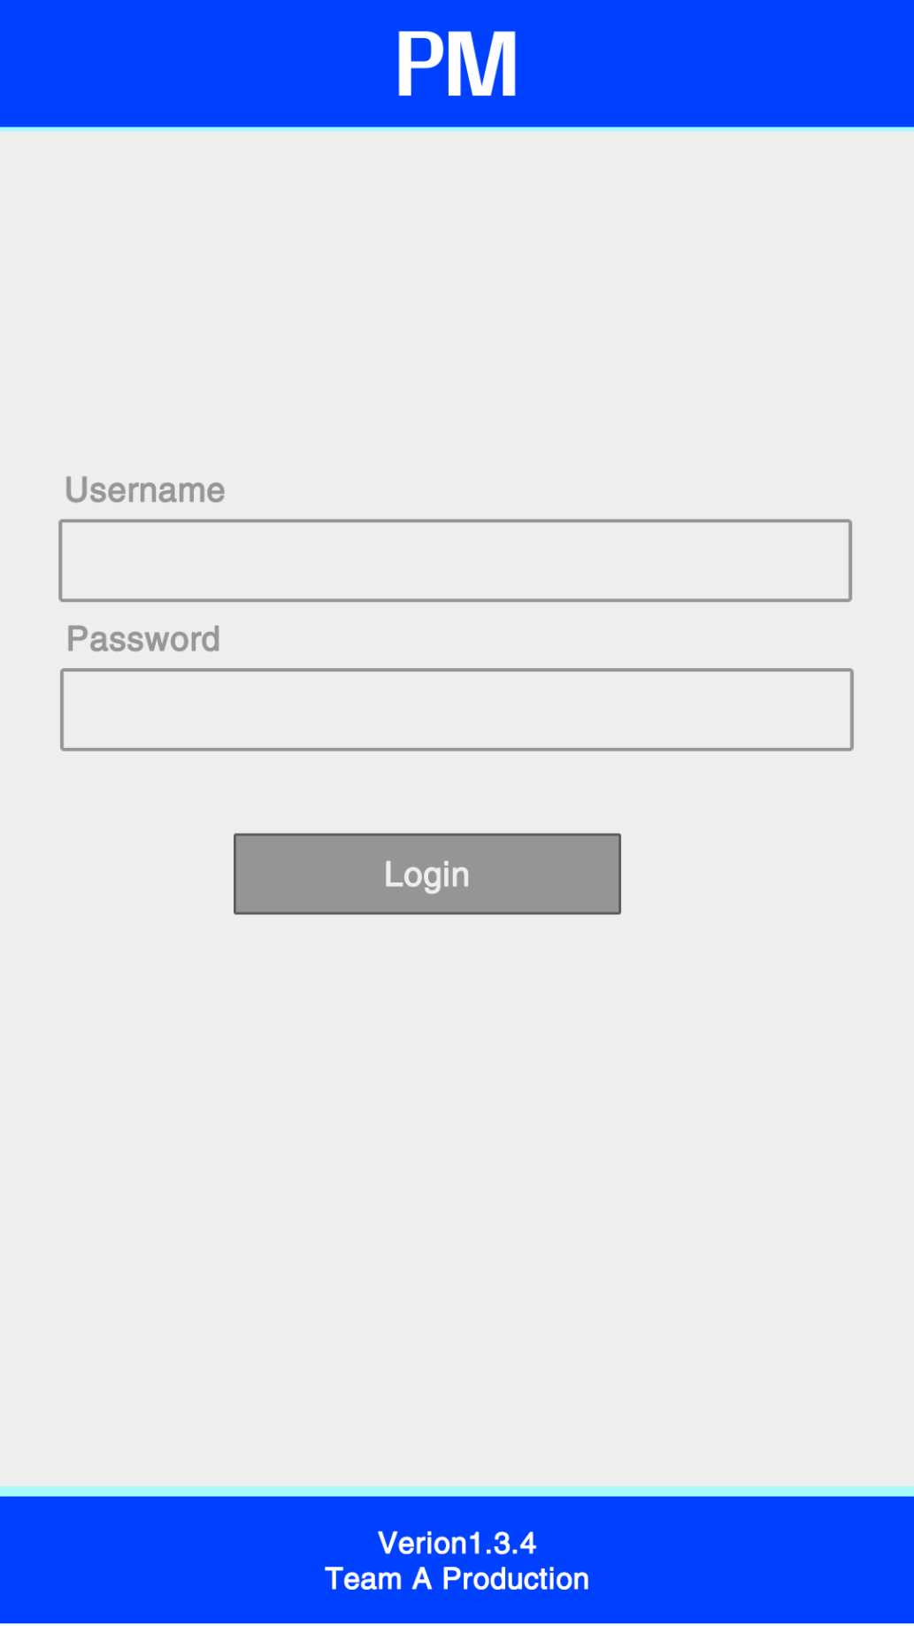

TUTORIAL

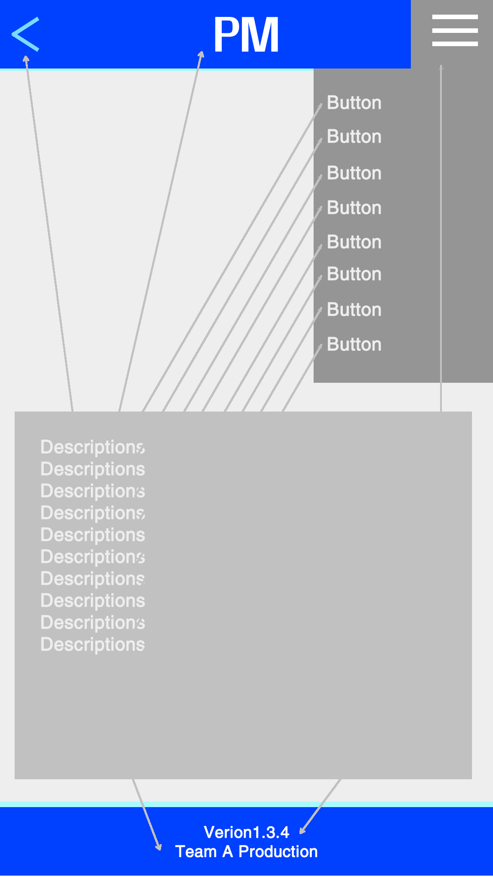

Main Menu

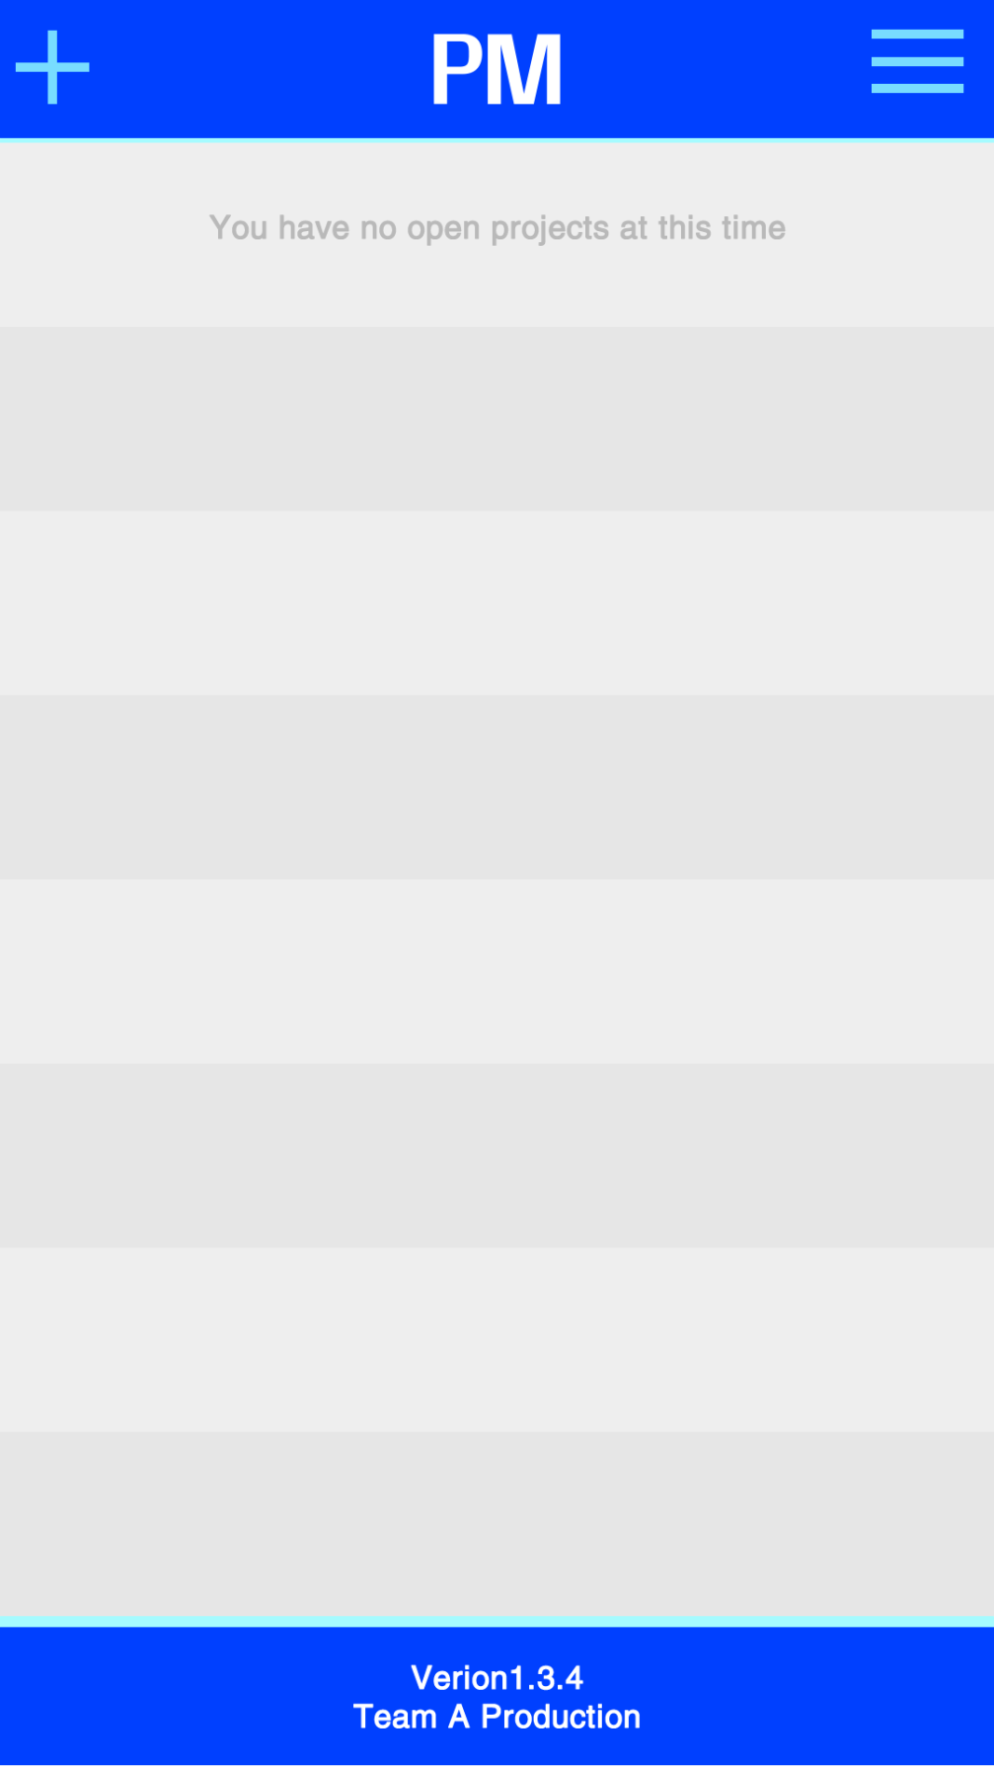

CREATE PROJECT

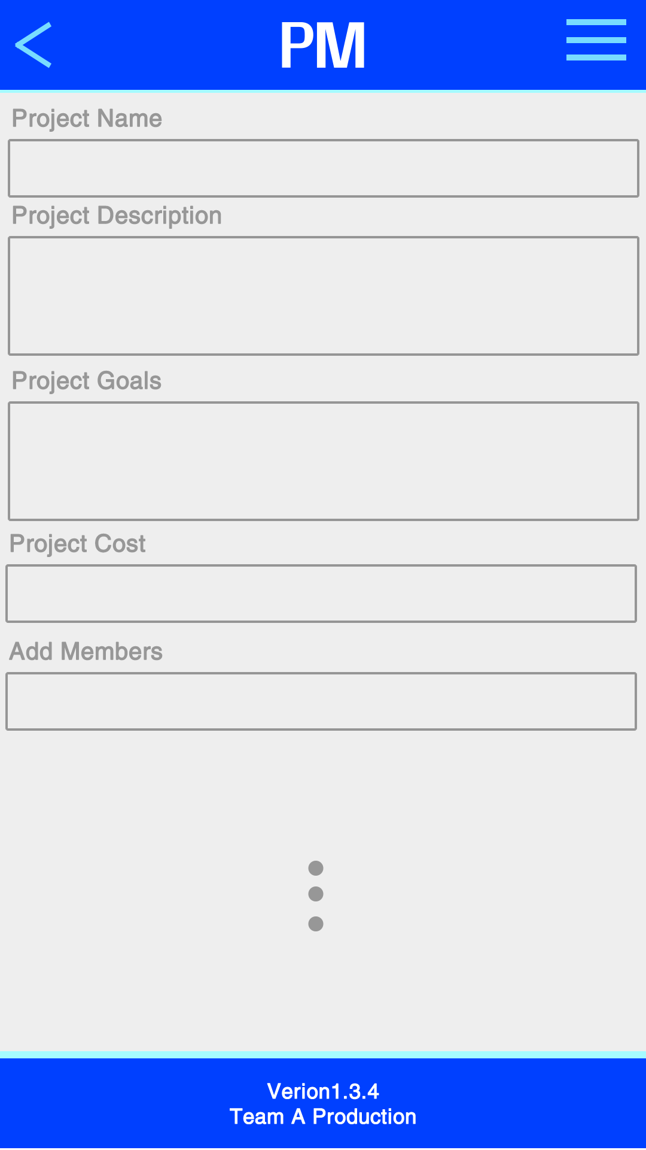

Project

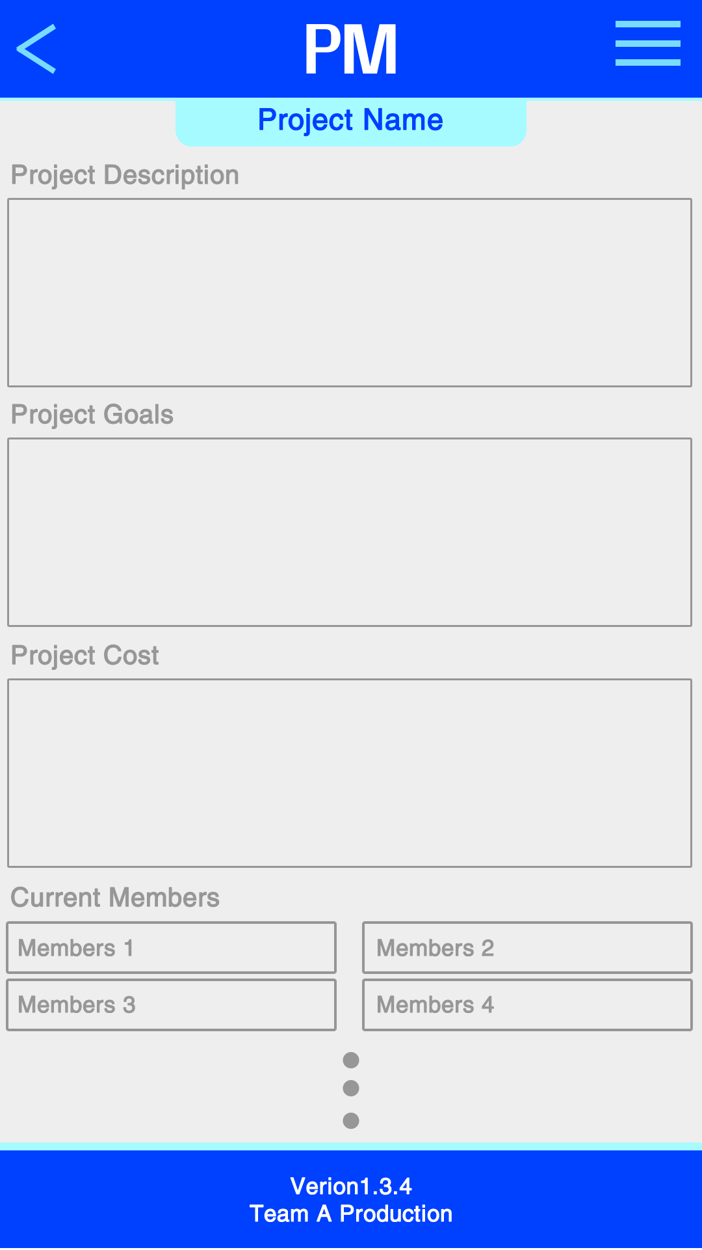

Profile

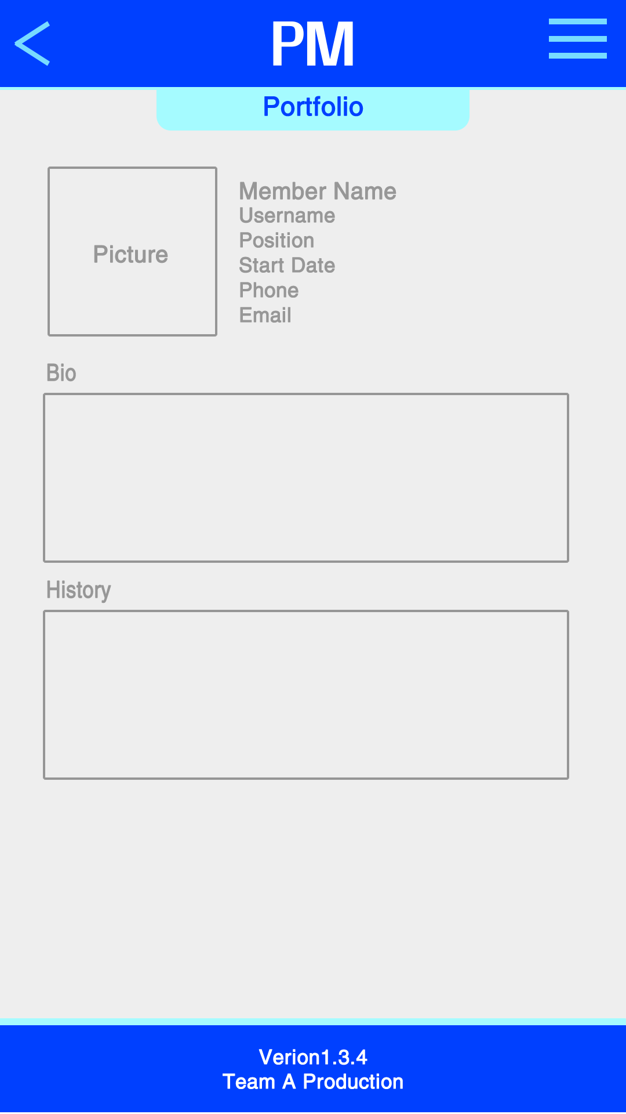

Member View

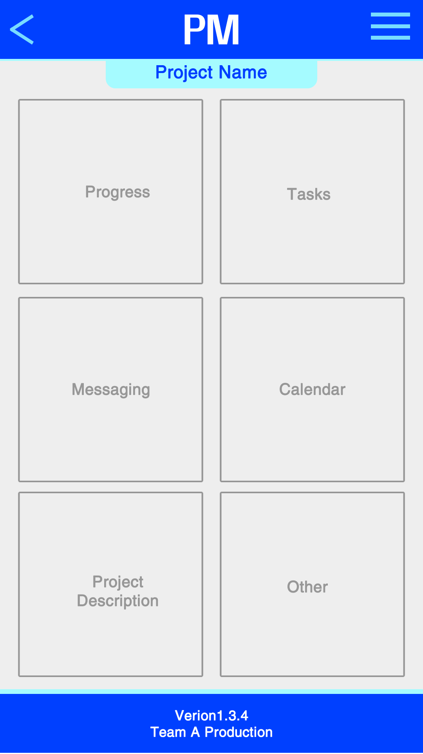

Leader View

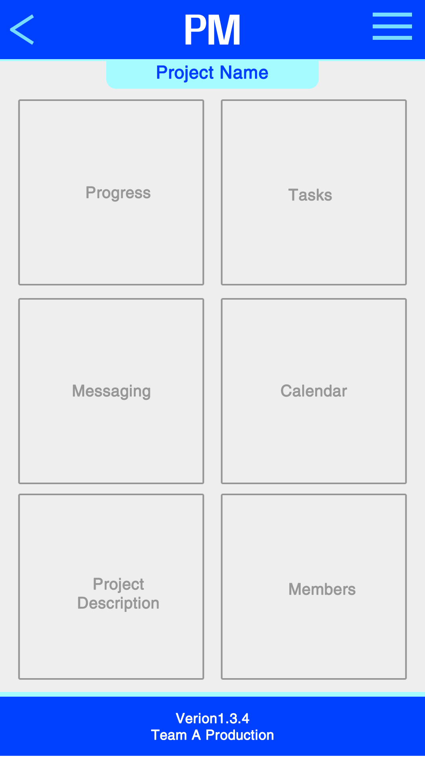

Progress

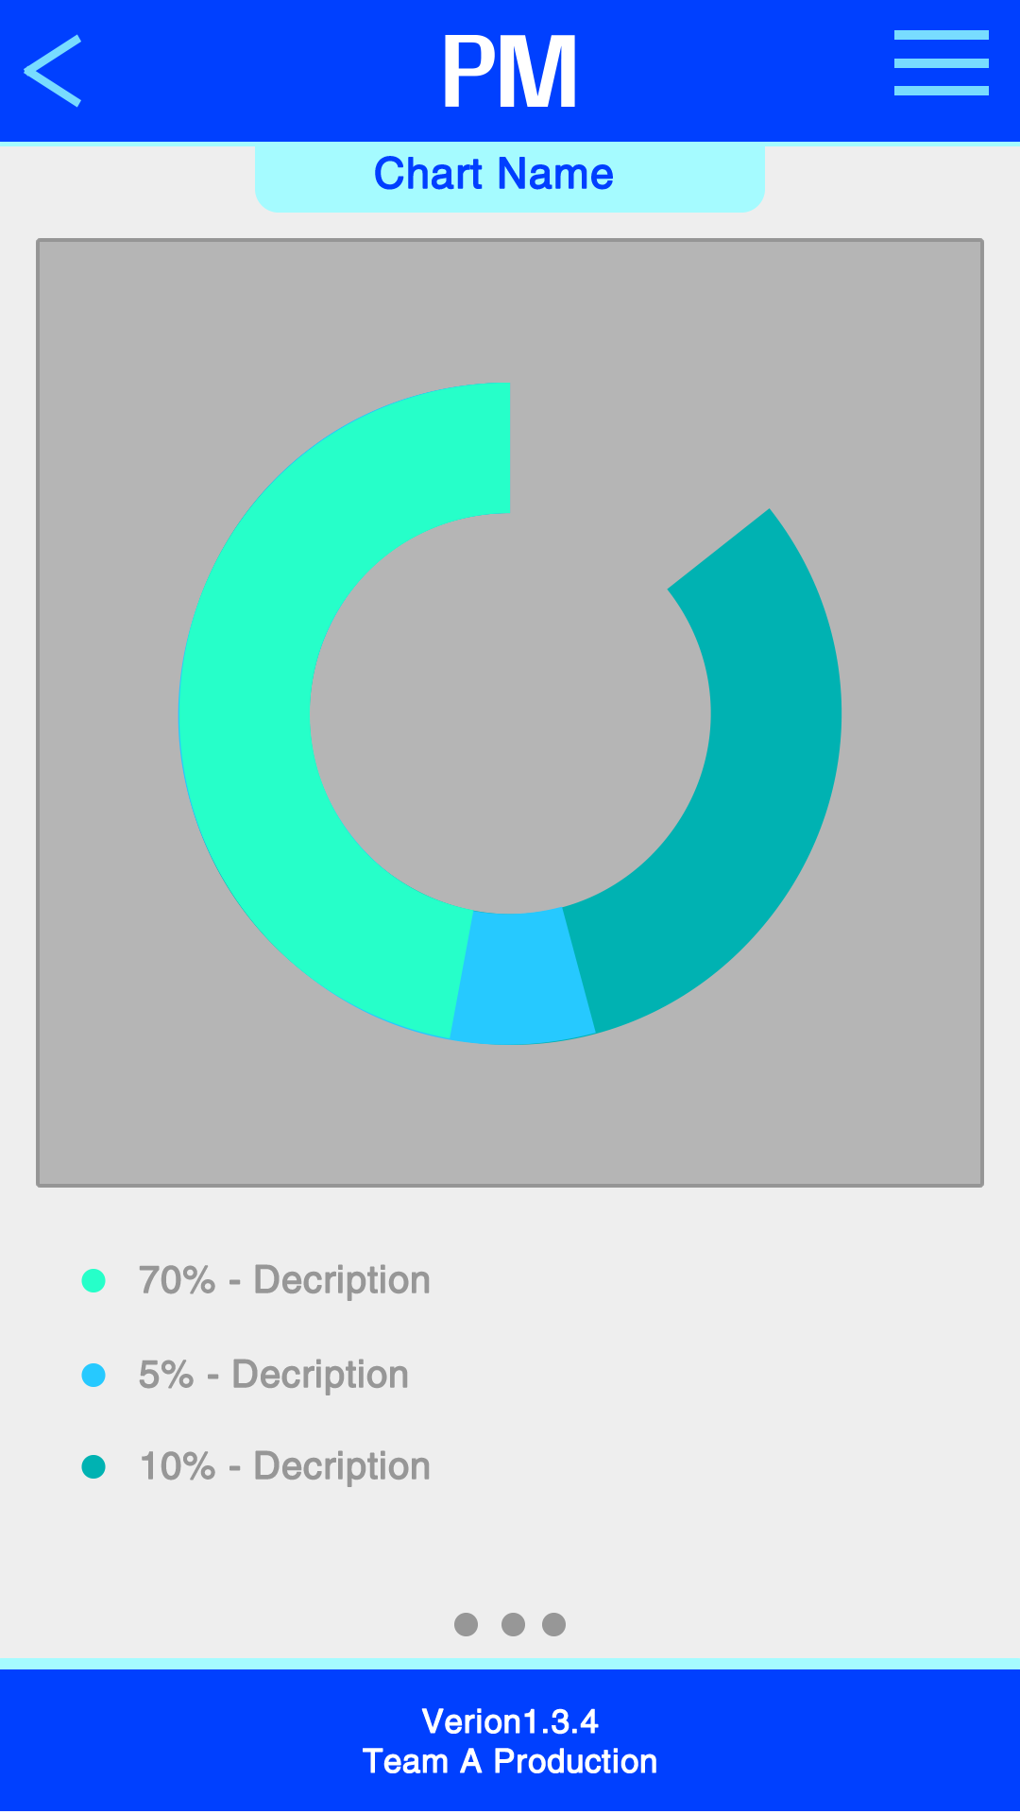

Calendar

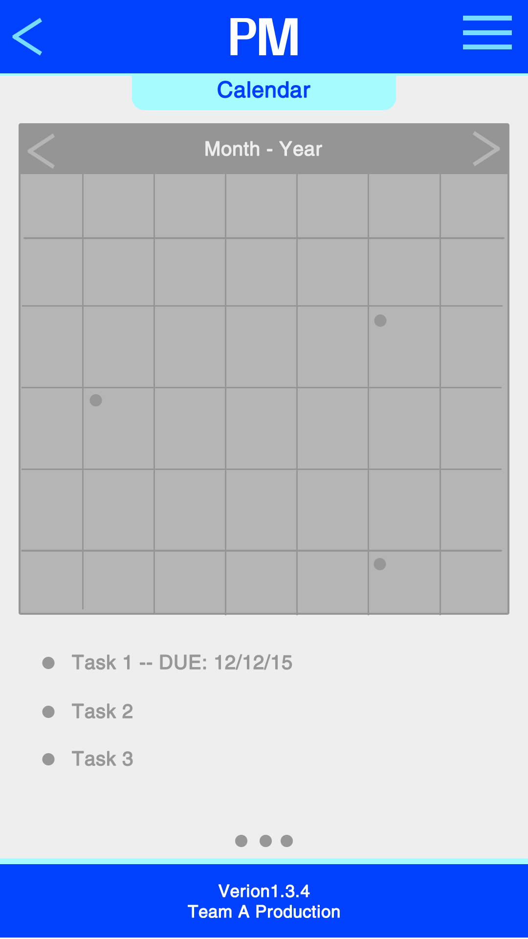

Task list

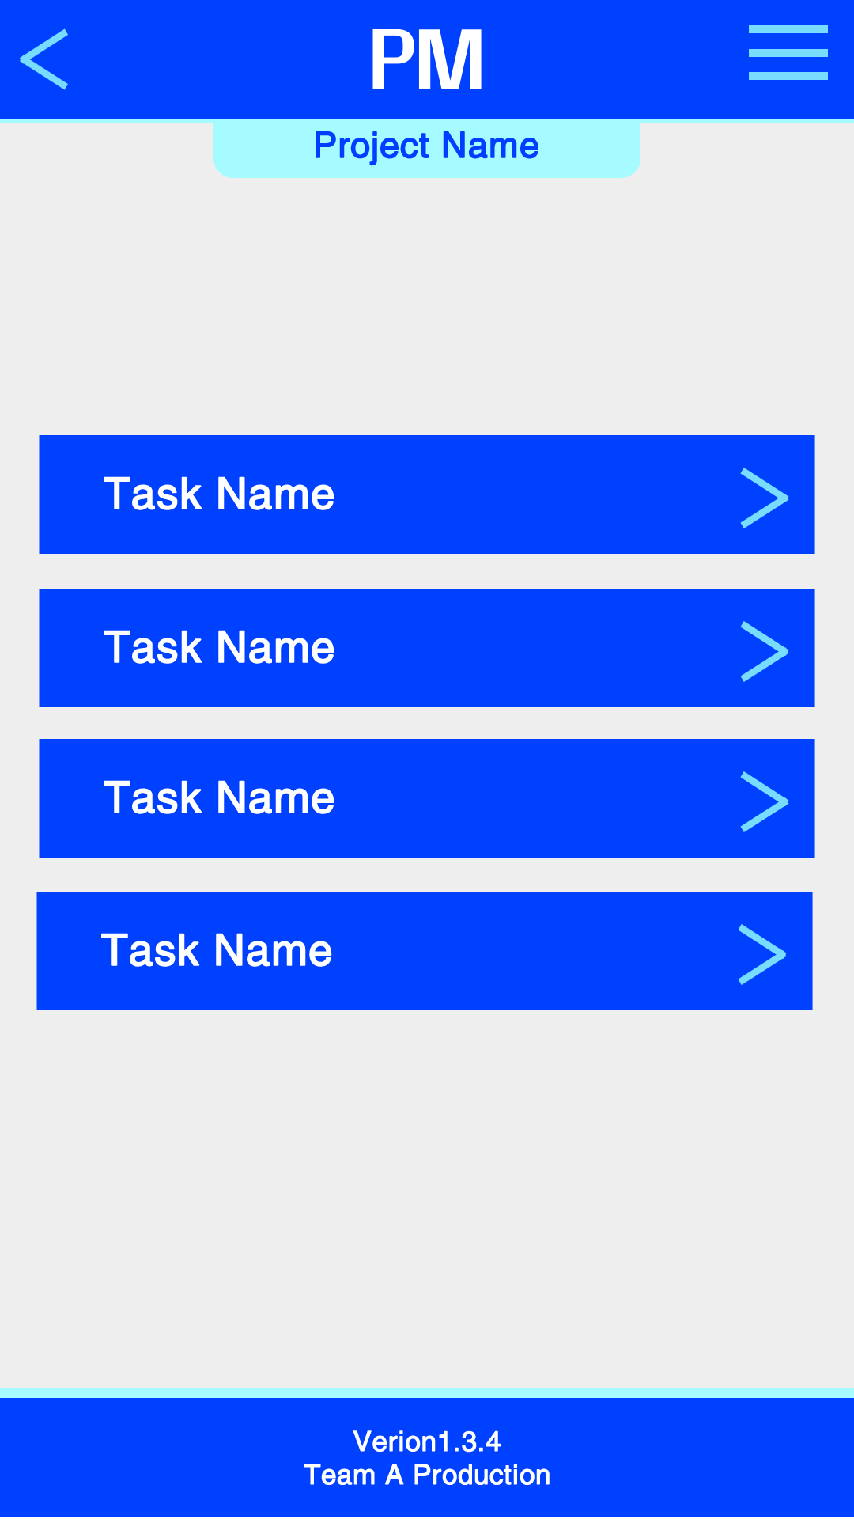

Mesageing

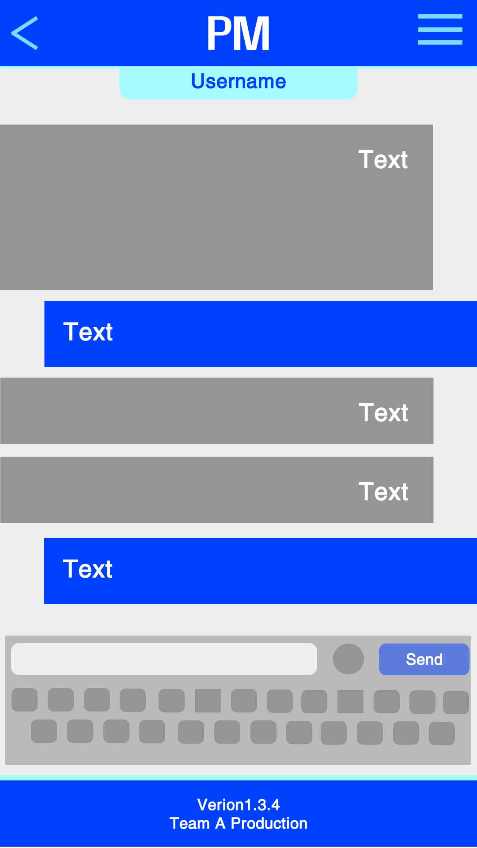

Member list

